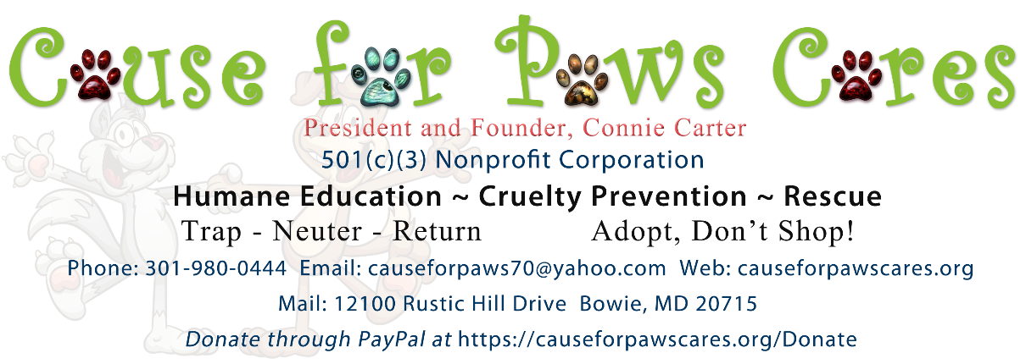
RESCUE CONTACT LIST
NOTE: This listing is provided as a courtesy only. Cause for Paws Cares, Inc., does not guarantee the accuracy of any information and is not responsible for changes or updates for the organizations listed. Please confirm contacts.
Animal Welfare League of Frederick County
1202 East Patrick Street, Suite 13A
Frederick, MD 21701
301-663-5855 (Barbara Wratten)
Ferals@AWLFC.org
Dawdesigns@aol.com

BARCS
Baltimore Animal Rescue and Care Shelter, Inc.
301 Stockholm Street
Baltimore, MD 21230
Web: www.barcs.org
Email: Info2.barcs@gmail.com
410-396-4695

Cat Rescue of Maryland (CROM) TNR Only
6400 Baltimore Nat'l PO Box 305
Baltimore, MD 21228
410-747-6595
www.catrescueofmd.org

Cats R Us Feral Cat Rescue
3127 Anchorage Drive
Annapolis, MD 21403
410-263-1719
MsKittyMeow@juno.com
www.petfinder.com/shelters/catrus.html

Community Cats Coalition
5 Windswept Drive
Berlin, MD 21811
www.communitycatscoalition.com

Community Cats Maryland, Inc.
PO Box 3637
Baltimore, MD 21214
410-753-9000
info@communitycatsmd.org
www.communitycatsmd.org

Friends of Montgomery County Animals
MD
301-977-4833
info@FMCA.org
www.FMCA.org

Four Legs Animal Hospital
1329 West Central Ave
Davidsonville, MD 21035
410-798-5222
www.FourLegs.net

Howard County Cat Club
Germantown, MD
howardcountycats@earthlink.net
www.howardcountycats.org

Kit Cat & Critter Rescue
PO Box 3542
Hagerstown, MD 21742
www.KitCatRescue.org

Maryland SPCA
3300 Falls Rd
Baltimore, MD 21211
410-235-8826
admissions@mdspca.org
adoptme@mdspca.org
www.mdspca.org

National Capital Area Spay & Neuter Center
1201 New York Avenue, NE
Washington, DC 20002
202-727-7369
catnip@wwashhumane.org
www.washhumane.org

NOVAPETSALIVE
Info@novapetsalive.com
4094 Majestic Lane #138
Fairfax, VA22033

Partnership for Animal Welfare
PO Box 1074
Greenbelt, MD 20768
301-572-4729
Paw_cats@yahoo.com
www.paw-rescue.org

PASSPORT ANIMAL RESCUE
Baltimore’s newest rescue organization
PO Box 44811
Nottingham, MD 21236
(email through website only)
Passportanimalrescue.org

Promise Animal League
132 Old National Pike
Hagerstown, MD 21740
301-465-9473
Star.silva@apromise.org
info@apromise.org
www.apromise.org

Rock Creek Cats
PO Box 203
Garrett Park, MD 20896
202-746-9682
rockcreekcats@yahoo.com
www.petfinder.com/shelters/rockcreekcats.html

SENIOR DOG SANCTUARY
Providing a permanent safe haven for senior dogs who are unable to be cared for by their owners, who are abandoned or abused, or face euthanasia.
8336 W B & A Rd,
Severn, MD 21144
http://www.seniordogsanctuary.com/
443-742-0270

SIAMESE RESCUE
Siamese Rescue is a coalition of shelters located in Virginia, California and Colorado that place Siamese cats through the US.
366 Meander Run Road
Locust Dale, VA 22948
Web: va.siameserescue.org
Email: vasrc@siameserescue.org
540-672-6373

SPCA OF ANNE ARUNDEL COUNTY
Animal protection organization in Annapolis
1815 Bay Ridge Avenue
Annapolis, MD 21403
Email: Through website Phone: 410-268-4388
Web: www.aacspca.org
SUNSHINE FRIENDS CAT RESCUE AND SANCTUARY, INC.
A non-profit organization dedicated to Community Cats: rescue, rehabilitate, rehome, refuge, reduce.
Jessup, MD 20794
www.sunshinescatrescue.org
Email: sunshinescatrescue@gmail.com
410-796-7327

THE GOOD SHEPHERD FERAL CAT SANCTURAY
A nonprofit organization specializing in feral rescue, relocation and sanctuary providing lifetime care for outdoor felines
32600 Landing Lane
Delmar, MD 21875
www.thegoodshepherdcatsanctuary.com
410-860-2280 (contact via phone only)

Throwaways' Rescue Foundation
PO Box 579
Waldorf, MD 20604
301-885-0025
Throwaways.Rescue@gmail.com
www.petfinder.com/shelters/throwaways.html

©2019 Cause for Paws Cares, Inc. web June 6, 2019

